*To : Samuel*

*Subject : Create a GitHub Action workflow -- Redha Devan Naratama – 9/8/2023*

*Hi Samuel,*

*Thanks for guiding me for this task today! Below is the task status :*

*1. Created new github repository*

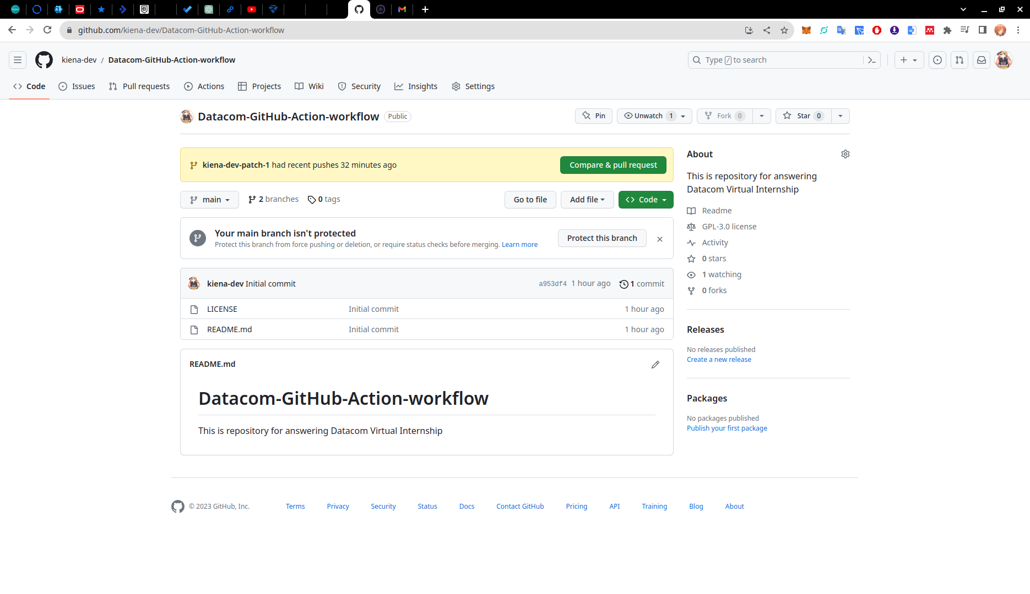*2. Read the terminal user guide, I’ve read and understand it~!*

*3. Download and install Git. I’ve also done configure the user and email.*

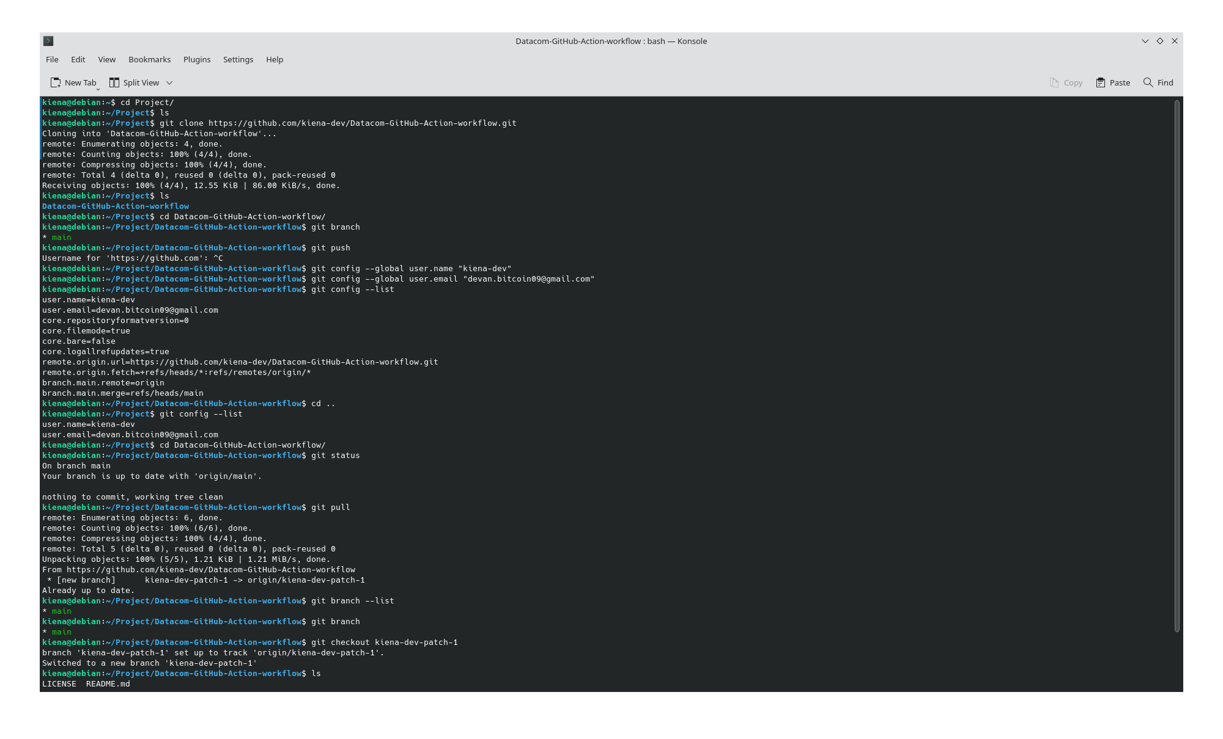*4. Clone the newly created empty repository to your local machine.*

**

*5. Understand the concept variables by following the link.*

*6. Create your first GitHub Actions workflow!*

*